**Media Streaming with IBM Cloud Video Streaming**

|  |  |
| --- | --- |
| **Date** | **26-10-2023** |
| **Team ID** | **675** |
| **Project Name** | **Media Streaming with IBM Cloud Video Streaming** |

**Media Streaming with IBM Cloud Video Streaming**

**Problem Definition and Design Thinking**

**Introduction**

We need to create an advanced online movie streaming platform using IBM Cloud Video Streaming. The platform should allow users to easily upload and watch their favorite movies and videos whenever they want. Our main goal is to enable people to enjoy movie nights with friends and family, no matter where they are. To make the movie-watching experience even better, we're dedicated to providing a smoothly integrated streaming service that ensures outstanding video quality, making users feel like they're in a real cinema.

In this document, we will outline the problem statement, the steps involved in solving it, and the design thinking approach that will guide our project.

**Problem Statement**

Develop a virtual cinema platform leveraging IBM Cloud Video Streaming capabilities. Empower users to effortlessly upload and stream their preferred movie titles and videos on a "just-in-time" basis. Facilitate the communal enjoyment of cinematic evenings with loved ones, regardless of their geographical dispersion. Enhance the art of cinematic viewing by providing uninterrupted streaming services and delivering top-tier video playback quality, culminating in an authentically immersive cinematic experience.

**Front-end Development**

**Step 1: Planning and Design**

**- Define Website Structure:** Begin by outlining the structure of your media streaming website. Identify the main pages, such as the home page, video library, live streaming, user profiles, and settings.

**- Wireframes and Mock-ups:** Create wireframes and mock-ups to visualize the website's layout and design. Wireframes are simple, low-fidelity sketches that help you determine the placement of elements on each page. Mock-ups, on the other hand, are high-fidelity representations of what the website will look like. Tools like Adobe XD, Sketch, or Figma can be useful for this.

**- Responsive Design:** Ensure your design is responsive, meaning it adapts well to different screen sizes, such as desktops, tablets, and mobile devices. This involves designing for various viewports and considering how elements rearrange or resize.

**Step 2: HTML/CSS Development**

**- HTML Templates:** Create HTML templates for the different pages you outlined during the planning phase. Use semantic HTML elements to structure your pages effectively. Each page should have a consistent layout, including headers, footers, and navigation.

**- CSS Styling:** Write CSS styles to make your website visually appealing and in line with the design you planned. Use CSS to control fonts, colors, layout, and overall aesthetics. Consider using CSS frameworks like Bootstrap for faster development.

**- Responsive Design Implementation:** Ensure that your website design is fully responsive. Use media queries to adjust styles and layout based on the device's screen size. Test your website on various devices to make sure it looks good everywhere.

**Step 3: User Interface (UI)**

**- Navigation Menus:** Implement navigation menus to allow users to move between different sections of your website. Include a clear, consistent menu structure with links to key pages.

- Video Library: Design and display your video library in an organized and visually appealing manner. Use grids or lists to showcase videos, and include essential details such as video titles, thumbnails, and descriptions.

**- Live Streaming:** Provide a user-friendly interface for live streaming, allowing users to view and interact with live broadcasts. Include features like chat, reactions, and user engagement tools.

**- User Profiles:** Create user profiles that allow users to customize their experience, save favorite videos, and manage their settings.

**Step 4: Interactive Elements**

**- Forms Validation:** Implement JavaScript to validate user input in forms, ensuring that they fill out required fields correctly. This prevents errors and improves the user experience, especially when users interact with forms to create accounts or make payments.

**- Dynamic Updates:** Use JavaScript to enable dynamic updates when users interact with videos or live streams. This includes features like pausing, seeking, volume control, and interactive elements during live broadcasts.

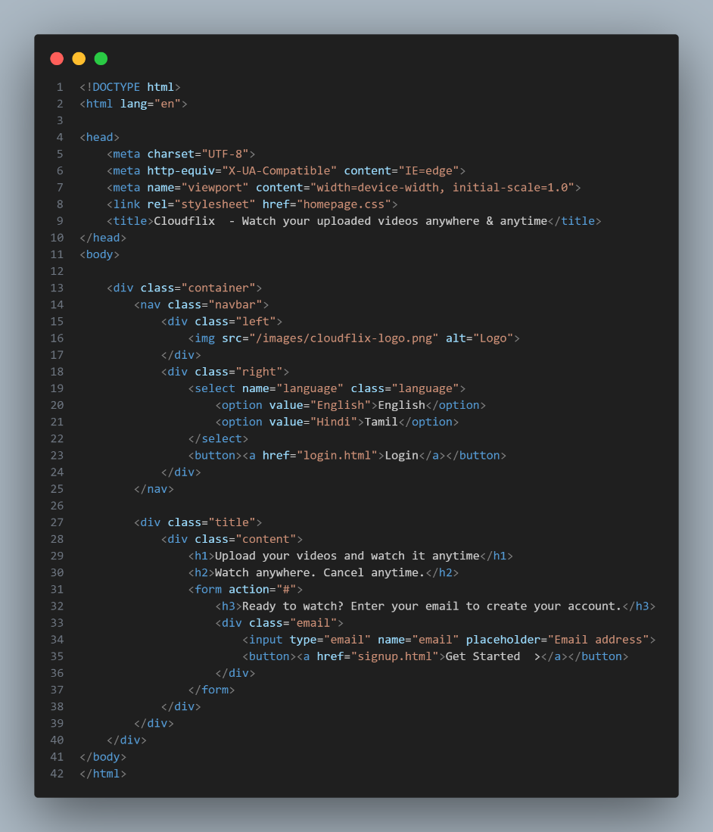

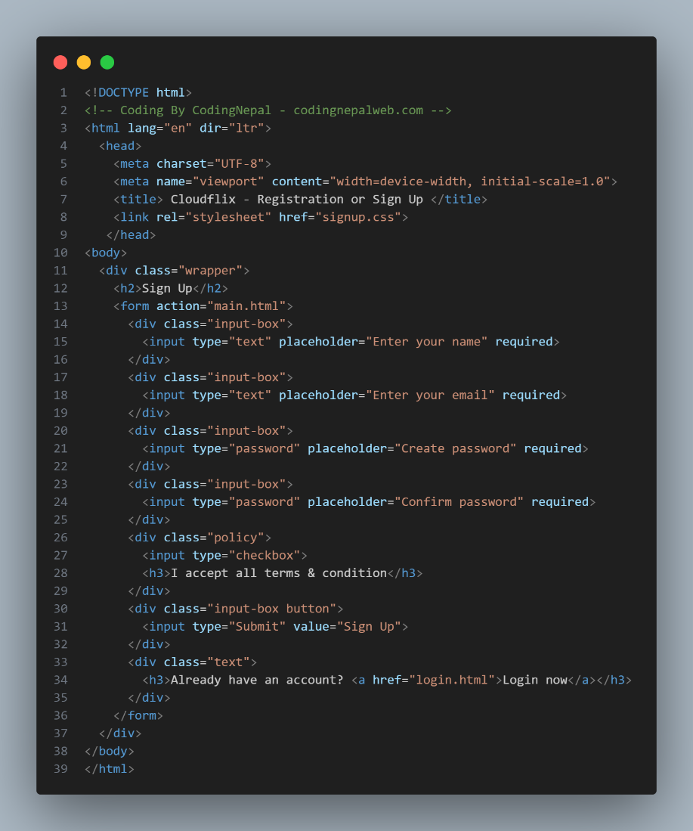

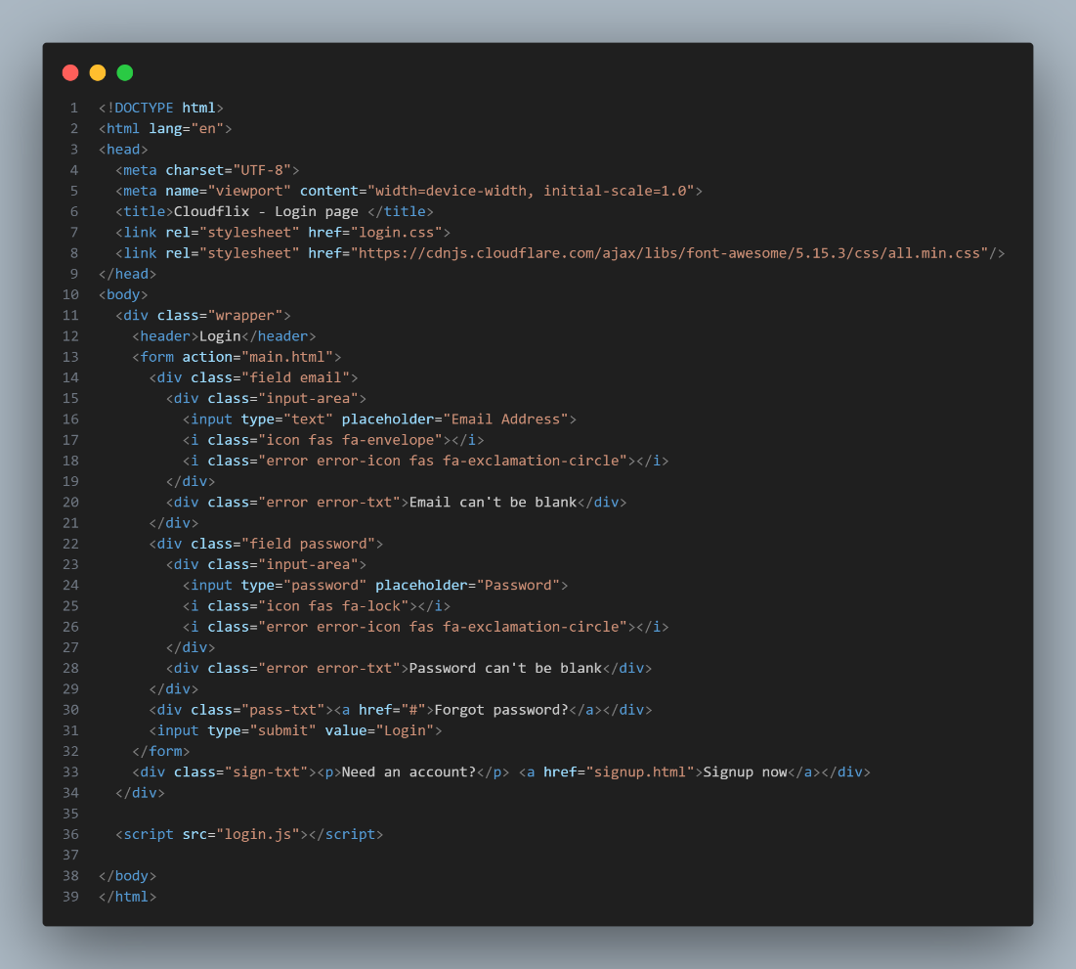

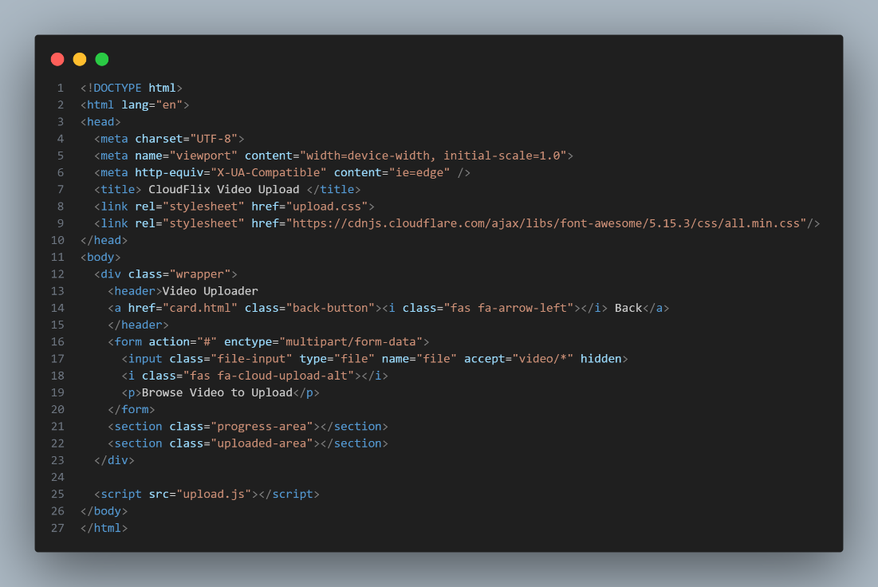

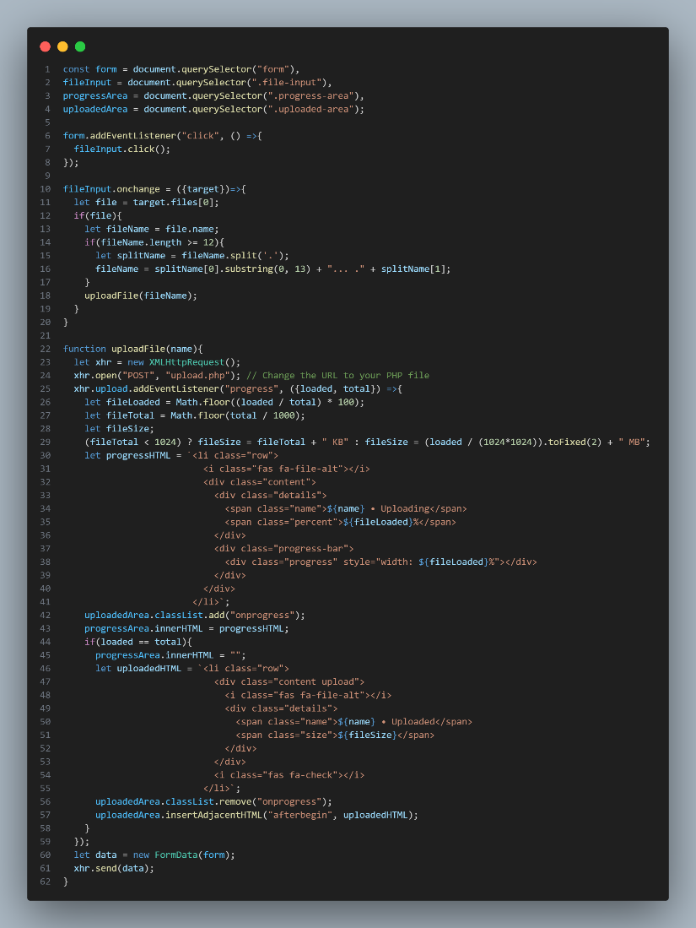

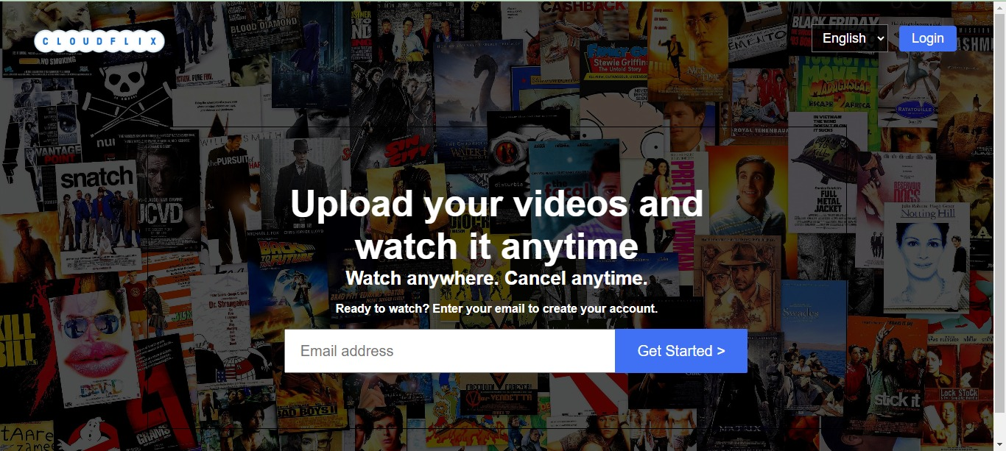

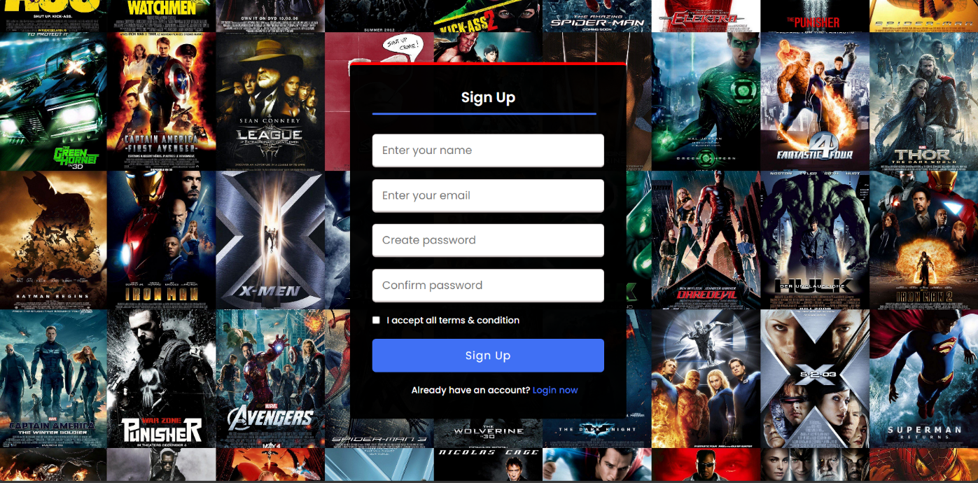

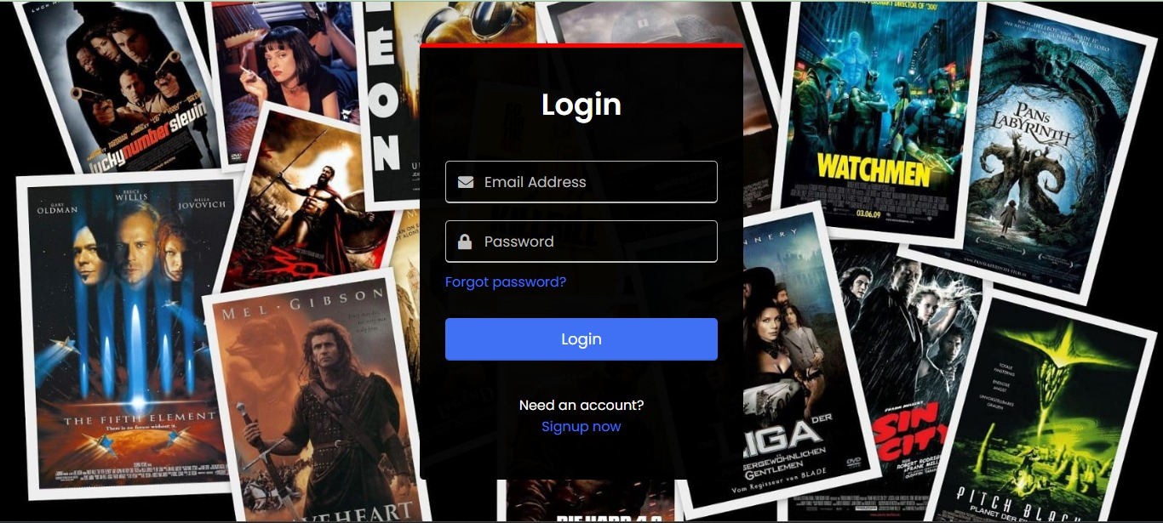

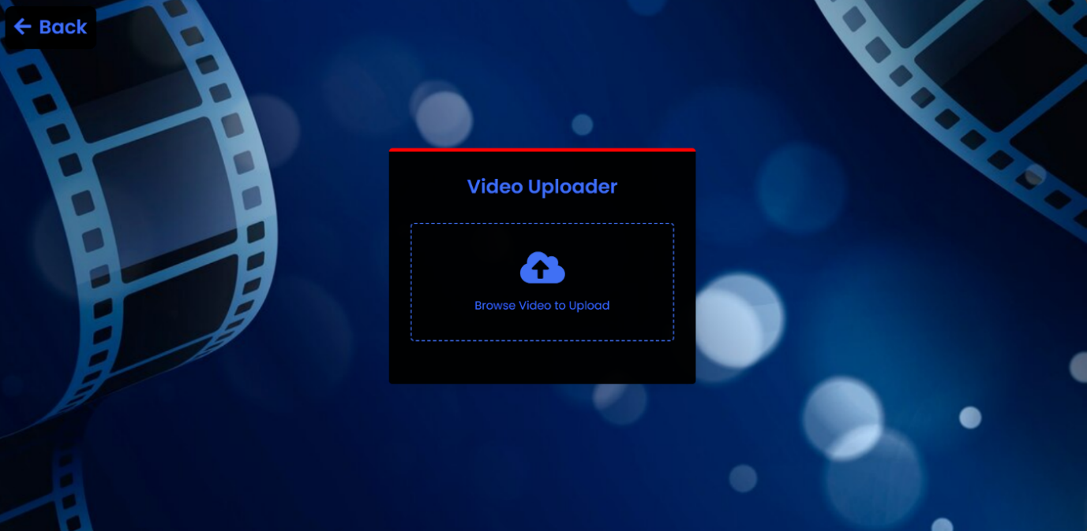

**Conclusion:**

In conclusion, the development of the frontend for our cloud-based media streaming was a meticulously executed endeavor. We embarked on this journey with a clear plan in mind, designing user interfaces that were not only visually appealing but also intuitive and user-friendly. Through a combination of HTML, CSS, and JavaScript, we created the web pages ensuring a good experience for our users.